**ASSIGNMENT-09**

**1. Create a view V_MARKS with roll no, STUDENT2053 name, SUBJECT2053 code, marks of all CSE STUDENT2053s.**

CREATE VIEW V_MARKS2053 AS

SELECT STUDENT2053.ROLLNO , STUDENT2053.NAME, SUBJECT2053.SUBJECTCODE

FROM STUDENT2053 , SUBJECT2053 , RESULT2053

WHERE STUDENT2053.ROLLNO = RESULT2053.ROLLNO AND RESULT2053.SUB_CODE = SUBJECT2053.SUBJECTCODE AND STUDENT2053.DEPTCODE = 'CSE';

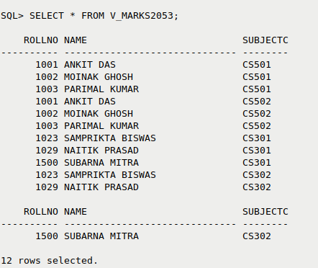

**2. Create a view V_CLASSTAKEN with SUBJECT2053 code, SUBJECT2053 name, Faculty code, faculty name where the SUBJECT2053 is taught by that faculty.**

CREATE VIEW V_CLASSTAKEN AS

SELECT SU.SUBJECTCODE, SU.SUBJECTNAME, SU.TEACHER , F.NAME

FROM SUBJECT2053 SU , FACULTY2053 F

WHERE SU.TEACHER = F.FID;

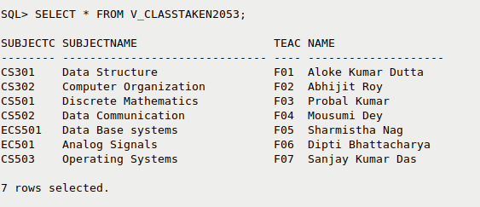

**3. Create view V_SUBJECT2053 with SUBJECT2053_code, SUBJECT2053_name, teacher name where the number of STUDENT2053 in the SUBJECT2053 is more than 1.**

CREATE VIEW V_SUBJECT2053 AS

SELECT S.SUBJECTCODE, S.SUBJECTNAME, F.NAME

FROM SUBJECT2053 S , FACULTY F

WHERE S.TEACHER = F.FID AND (SELECT COUNT(*) FROM STUDENT2053 ST WHERE ST.SEMESTER = S.SEMESTER

AND ST.DEPTCODE = S.DEPTCODE) > 1;

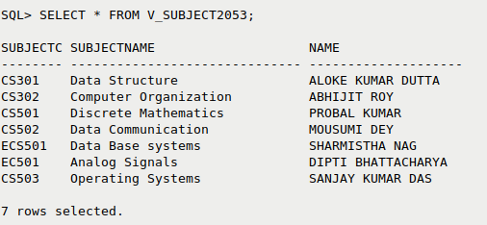

**4. Create a view V_STUDENT2053 with STUDENT2053 name, roll number, department who appeared in at least one examination.**

CREATE VIEW V_STUDENT2053 AS

SELECT S.NAME , S.ROLLNO, S.DEPTCODE

FROM STUDENT2053 S

WHERE (SELECT COUNT (*) FROM RESULT2053 R WHERE R.ROLLNO=S.ROLLNO) >= 1;

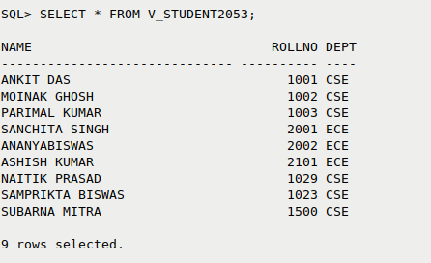

**5. Create a view V_DEPT with dept code, semester, number of STUDENT2053 with more than 75 marks in at least one SUBJECT2053.**

CREATE VIEW V_DEPT AS

SELECT S.DEPTCODE, S.SEMESTER, COUNT(*) AS STUDENT_COUNT

FROM STUDENT2053 S

WHERE (SELECT COUNT(*) FROM RESULT2053 R WHERE S.ROLLNO = R.ROLLNO AND R.MARKS > 75) > 1

GROUP BY S.DEPTCODE, S.SEMESTER;

